AI Assisted Coding
Assignment 8.1: Test-Driven Development with AI – Generating and Working with Test Cases
Name:Kanneboyina Meghana
Batch-44
HTNO:2303A52345
Task 1: (Password Strength Validator – Apply AI in Security Context)
Prompt:Generate assert-based test cases for a Python function is_strong_password(password) that validates length ≥ 8, includes uppercase, lowercase, digit, special character, and rejects spaces.
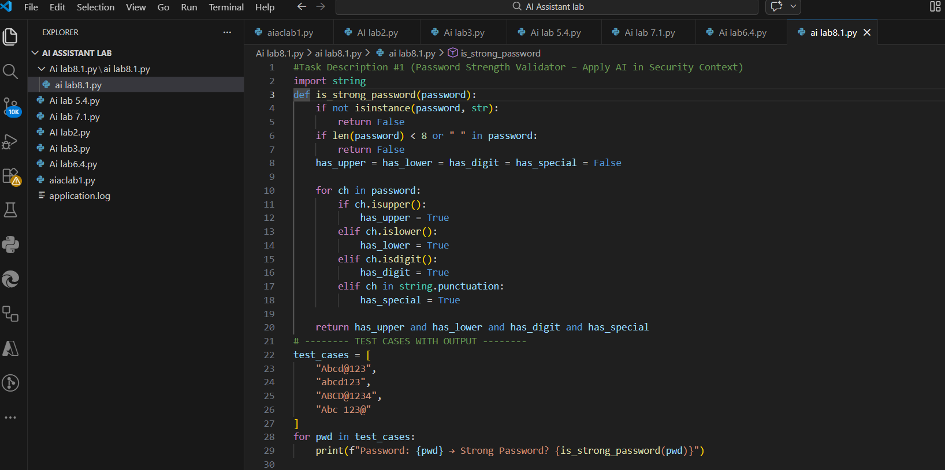
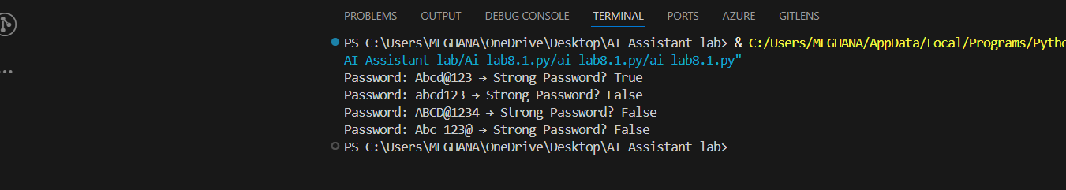
Explanation:
1.AI is used to generate test cases before implementing the function, following Test-Driven Development.
2.The function checks if the password length is at least 8 characters.
3.It verifies the presence of uppercase, lowercase, digit, and special characters.
4.Spaces in the password are not allowed.
5.The function returns True for a strong password and False otherwise.
Task 2: Number Classification with Loops (Edge Case Handling)
Prompt: Generate assert-based test cases for a Python function classify_number(n) that classifies numbers as Positive, Negative, or Zero and handles invalid inputs like strings and None.
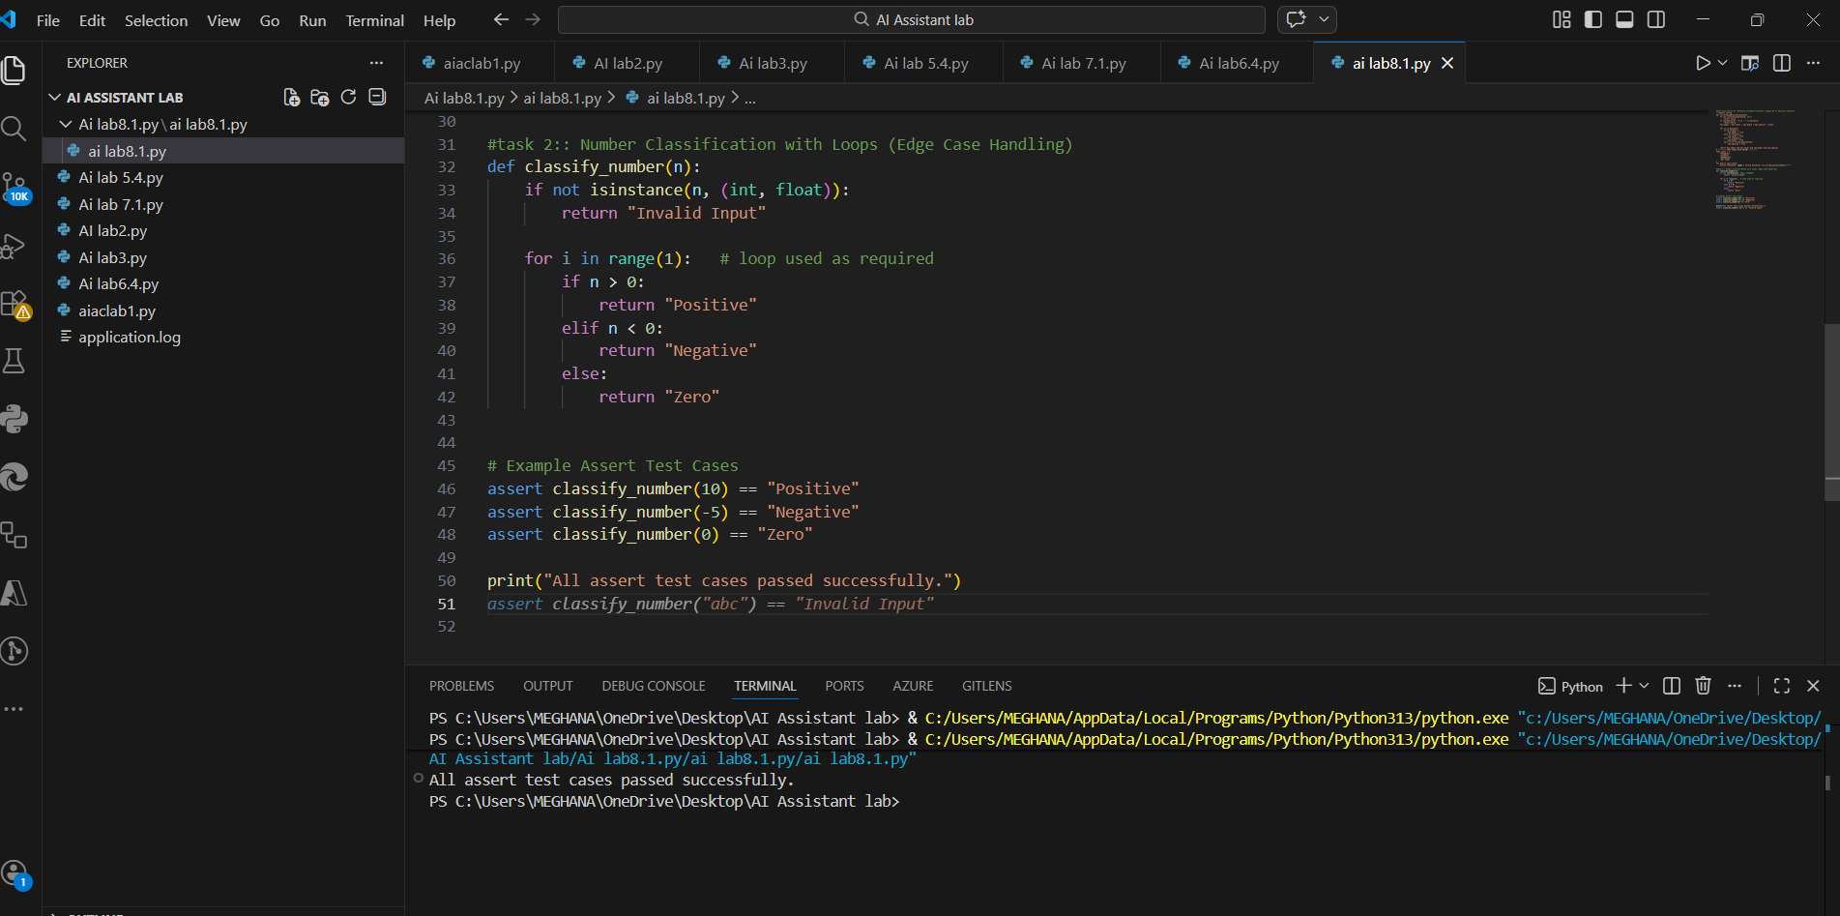
Explanation:
1.AI is used to generate assert-based test cases before writing the function.
2.The function classify_number() classifies a number as Positive, Negative, or Zero.
3.A loop is used to satisfy the problem requirement.
4.Boundary values such as -1, 0, and 1 are handled correctly.
4.Invalid inputs like strings and None return "Invalid Input".
5.All assert test cases pass successfully, validating the logic.

Task 3 :(Anagram Checker – Apply AI for String Analysis)
Prompt: Generate assert-based test cases for a Python function is_anagram(str1, str2) that ignores case, spaces, and punctuation and handles empty strings.
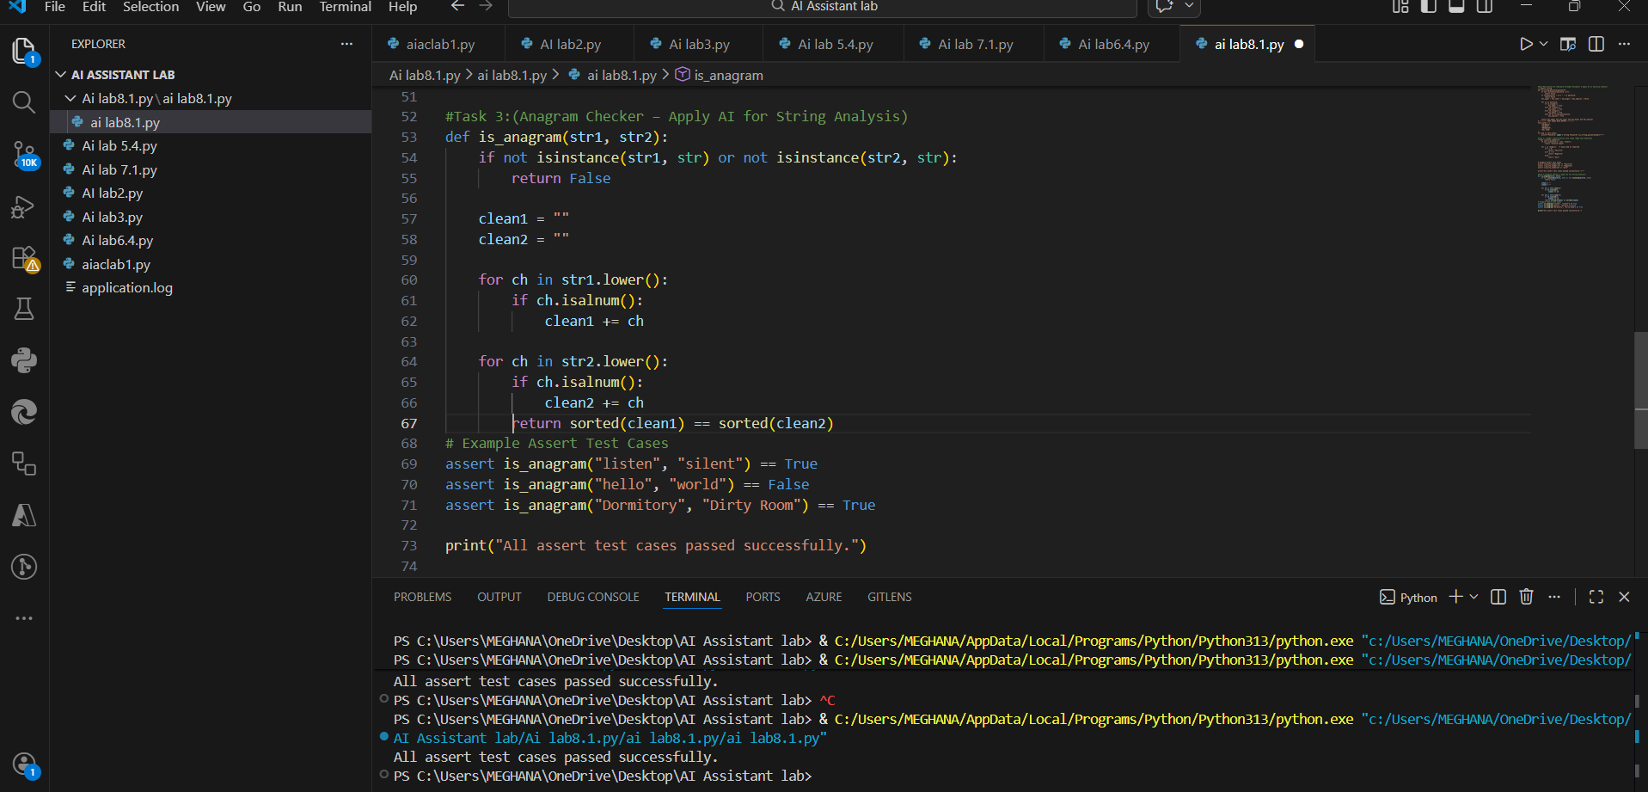
Explanation:
1.AI is used to generate test cases before implementing the function.
2.The function removes spaces and punctuation and converts strings to lowercase.
3.Characters are compared after sorting to check for anagrams.
4.Edge cases like different words and mixed case inputs are handled.
5.All AI-generated assert test cases pass successfully.
Task4 :(Inventory Class – Apply AI to Simulate Real-World Inventory System)
Prompt: Generate assert-based test cases for a Python Inventory class that supports adding items, removing items, and checking stock quantities.
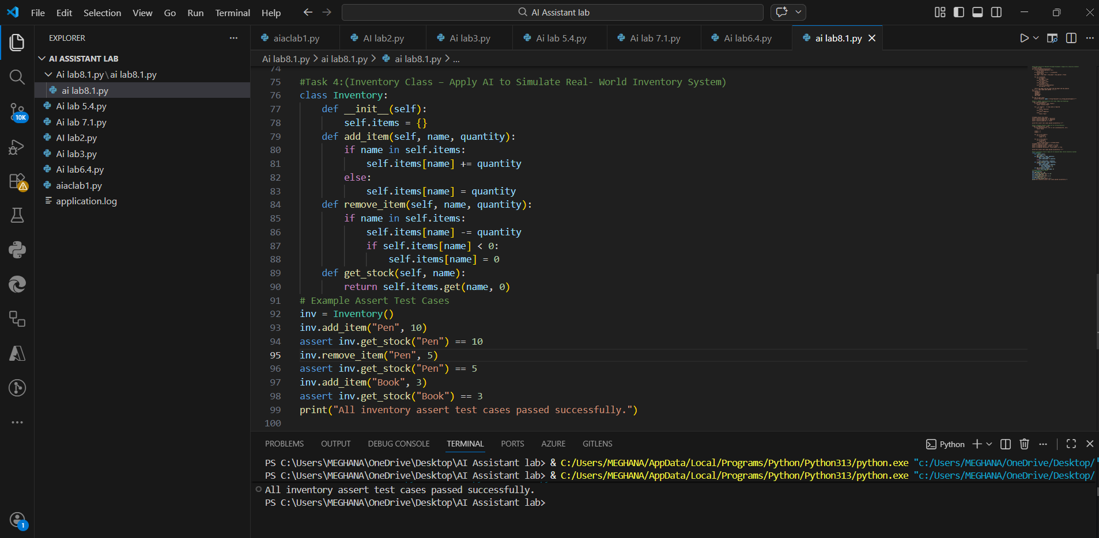
Expalantion:
1. AI is used to generate assert-based test cases before implementing the class.
2.The Inventory class stores item names and quantities using a dictionary.
3.add_item() adds new items or updates existing stock.
4.remove_item() reduces stock and prevents negative values.
5. get_stock() returns the current quantity of an item.
6.All assert test cases pass, proving correct inventory functionality.
Task 5: (Date Validation & Formatting – Apply AI for Data Validation)
Prompt: Generate assert-based test cases for a Python function validate_and_format_date(date_str) that validates MM/DD/YYYY format, handles invalid dates, and converts valid dates to YYYY-MM-DD.
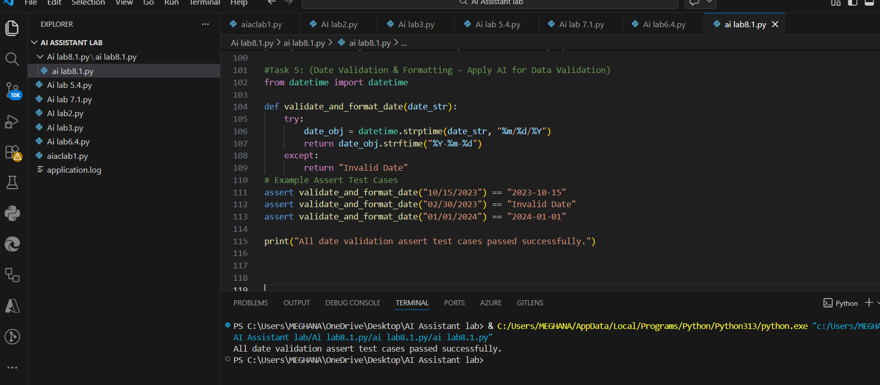
Explanation:
1.AI is used to generate test cases before implementing the function.
2.The function validates the date format using MM/DD/YYYY.
3.Invalid dates such as February 30 are handled using exception handling.
4.Valid dates are converted to YYYY-MM-DD format.
5.All AI-generated assert test cases pass successfully.

